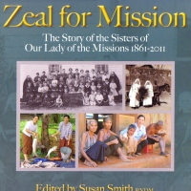
RNDM publications

Zeal for Mission
The Story of the Sisters of Our Lady of the Missions
1861-2011
Edited by Susan Smith RNDM
Published 2012 - David Ling
Dedication Reads: This book is dedicated to the Sisters of Our Lady of the Missions: those who have gone before us and from whom we can learn so much; those who today look to the past with gratitude and to the future with hope as they live out the RNDM charism in their lives; and those who will join the Congregation and in fidelity and courage continue to witness to the reign of God.

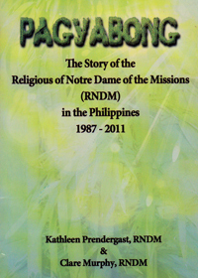
Pagyabong
The story of the establishment of the RNDM Sisters in the Philippine Region 1987-2011. This missionary journey is a sharing of hope and commitment.
By Kathleen Prendergast RNDM and Clare Murphy RNDM
Published 2011 Claretian Publications

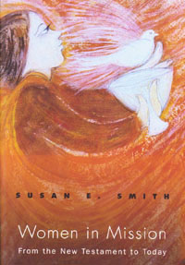

Women in Mission
This book considers the significant role of missionary women in the Catholic Church. This history of mission highlights the critical contributions of women and the Theological developments which influenced their role. This work seeks to understand the important role of women since the New Testament to the present.
By Susan E. Smith
Published 2007 Orbis Books

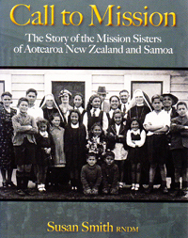

Called to Mission
The Story of the Mission Sisters in Aotearoa New Zealand and Samoa. The history of the Sisters is traced from the time of the arrival of the founding Sisters in 1865 to the present.
By Susan Smith RNDM
Published 2010 David Ling

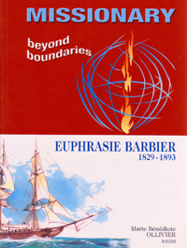

Missionaries Beyond Boundaries
This is the most recent and comprehensive biography of Euphrasie Barbier tracing the life and times of the Foundress of the Congregation of Our Lady of the Missions.
By Marie Bénédicte Ollivier RNDM
Published 2007 Tipolito: Salesian Institute
Available in English and French

The Greastest Surprise
The Greatest Surprise is written to help young children appreciate that God, as a God of Love and Surprise, is with us all in death as well as in life. It will also help them as they grieve the death of a family member or friend
By Mary Evans
Published 2005

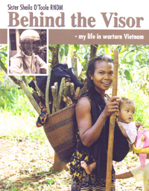

Behind the Visor - my life in war-torn Vietnam
Sister Sheila records her own experiences and that of our RNDM Sisters during the terrible events that marked the conflict in South Vietnam from 1969 and then her work among the people until 2003.
By Sheila O’Toole RNDM
Published 2007 Print House Ltd

Euphrasie
This book is a simplified, easy to read, version of the life of Euphrasie Barbier the Foundress of the Congregation of Our Lady of the Missions. It is beautifully illustrated by the author. A colouring-in book is also available.
The Biography is now also in Burmese.
By Mary Philippa Reed, RNDM
Printed in 2007

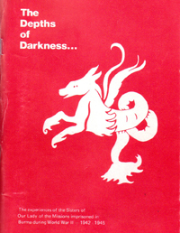

The Depths of Darkness
The experiences of the Sisters of Our Lady of the Missions imprisoned in Burma during World War II 1942-1945 are recounted. While the title is “The Depth of Darkness” it could just as well be “Survival in Hope.”
By Marguarite Dwane RNDM
Published 2007 Print House Ltd

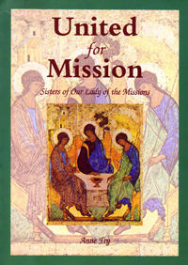

United for Missions
The experiences of the Sisters of Our Lady of the Missions imprisoned in Burma during World War II 1942-1945 are recounted. While the title is “The Depth of Darkness” it could just as well be “Survival in Hope.”
By Marguarite Dwane RNDM
Published 2007 Print House Ltd

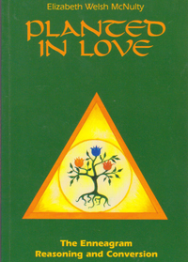

Planted in Love
The book is a simple and direct presentation of the enneagram which provides the individual with a profound depth of insights into the mysteries of their own manner of being.
By Elizabeth McNulty RNDM
Published 1995 St. Pauls

These Have I loved
The Congregation of Our Lady of the Missions in Australia has counted more than 270 members. From that number twelve have been selected and their stories range from Pakistan, Burma, Vietnam as well as the whole length of Australia, New Zealand, Wales and Ireland.
By Mary Sebastian Maher RNDM
Published 1985 The Gazette Printing Co 1985

My Life ... Mission
The Story of the life of Euphasie Barbier in cartoon format with additional material on the present work and mission of the Congregation.
Available in English, French, Spanish and Burmese
Edited by Marie Bénédicte Ollivier and Marie Laurent Vonlanthen
Published 1984 Sadifa

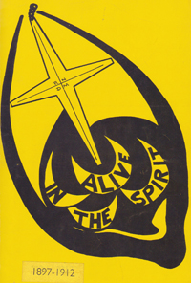

Alive in the Spirit
The history of the first fifteen years of the Sisters of Our Lady of the Missions in Western Australia 1897-1912
By Mary Sebastian Maher RNDM
Published 1985 The Gazette Printing Co 1979

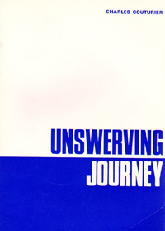

Unswerving Journey
This is the life of Mother Mary of the Heart of Jesus (Euphrasie Barbier) – Foundress of the Congregation of Our Lady of the Missions.
By Charles Couturier
Published 1966 Piere et Vie Toulouse

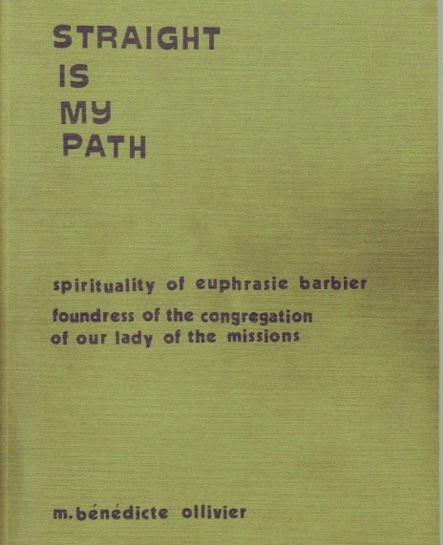

Straight is My Path
This book focusses on the spirituality of Euphrasie Barbier, Foundress of the Congregation of Our Lady of the Missions. Using the … of Euphrasie Barbier – this work discovers her depth of spirituality which we cannot fail to admit.
By Marie Bénédicte Ollivier RNDM
Published 1978
Available in English and French

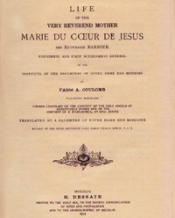

Life of Marie du Coeur de Jesus
The first biography of the life of Euphrasie Barbier 1829-1893 Foundress
of the Congregation of Our Lady of the Missions
By l’Abbé A. Coulomb
Published 1914 H. Dessain

