RNDM BANGLADESH PROVINCE

PROFILE-2023

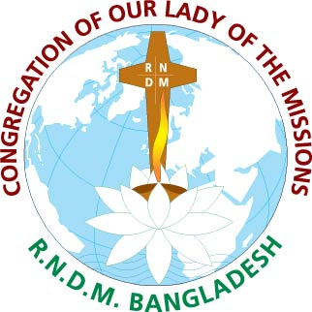

24, Asad Avenue, Mohammadpur, Dhaka-1207

BRIEF HISTORY OF

BANGLADESH PROVINCE

25 March 1883

Arrival of Euphrasie and 5 Pioneer Sisters

Indian Province (British India)

Provincial House: Chittagong

Novitiate House: Chittagong

14 August 1947

British India partitioned

India Pakistan

Province: East Pakistan

Provincial House: Chittagong

Province comprises of East Pakistan: India and Myanmar

Novitiate for three countries: Chittagong

Mid 1964

War between India and Pakistan forces

Indian Sisters to leave the then East Pak

istan, Hence

Province divides into three regions

Burma East Pakistan India

1965

Provincial House: Chittagong, East Pakistan

Novitiate House: Chittagong

16 December 1971

Provincial House: Chittagong, Bangladesh

Novitiate House: Chittagong

1993

Provincial House moves to Dhaka

Novitiate House: Chittagong

Statistics: April 2007

104 PP Sisters + 8 on International Mission

35 TP Sisters and 4 Novices?

Statistics: February 2008

105 PP + 8 on International Mission

34 TP Sisters + 4 Novices, 2 Postulants, 20 Aspirants

Statistics: May 2023

103 PP + 8 on International Mission

14 TP Sisters + 3 Novices, 5 Postulants, 22 Aspirants

BANGLADESH PROVINCE

LEADERSHIP TEAM (2021-2024)

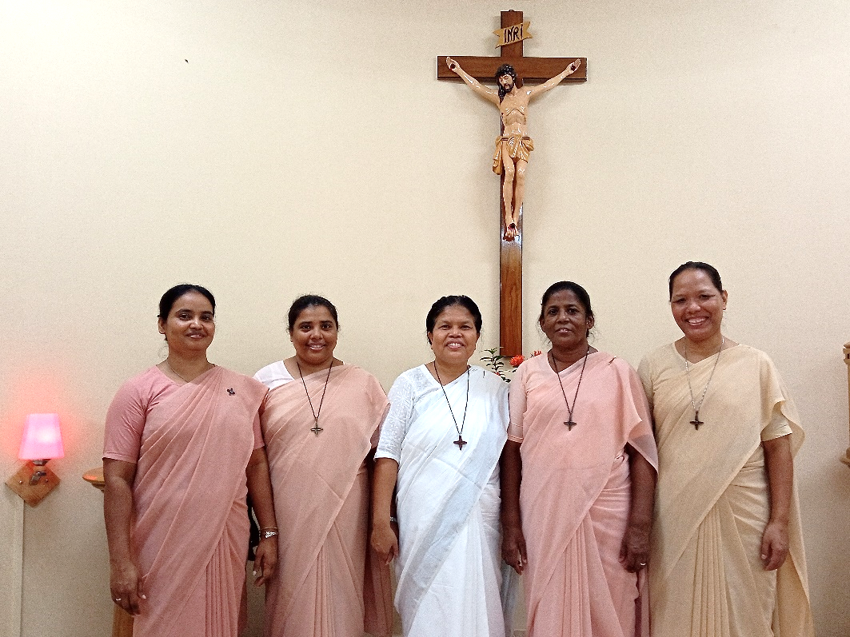

From the left:

Sr. Himani E. Rozario, RNDM, Sr. Suchitra B. Rozario, RNDM, Sr.Purobi Pascalina Chiran, RNDM, (Provincial) , Sr. Niva M. Gomes, RNDM, Sr. Mohini A. Pathang, RNDM,

Bangladesh National Anthem

My Bengal of Gold, I love you.
Forever yours skies,
Your air set my heart in tune,
As if it were a flute.

In spring, O mother mine,
The fragrance from your mango groves,
Makes me wild with joy,
Ah, what a thrill!
In a autumn, O mother mine,
In the full blossomed paddy fields,
I have seen spread all over sweet smiles.

Ah, what beauty, what shades,
What an affection and what tenderness!
What a quilt have you spread
At the feet of banyan trees
And along the banks of rivers!

Oh mother mine, words from your lips
Are like nectar to my ears.
Ah, what a thrill!

If sadness, O mother mine,
Casts a gloom on your face,
My eyes are filled with tears!
O Golden Bengal, I love you.

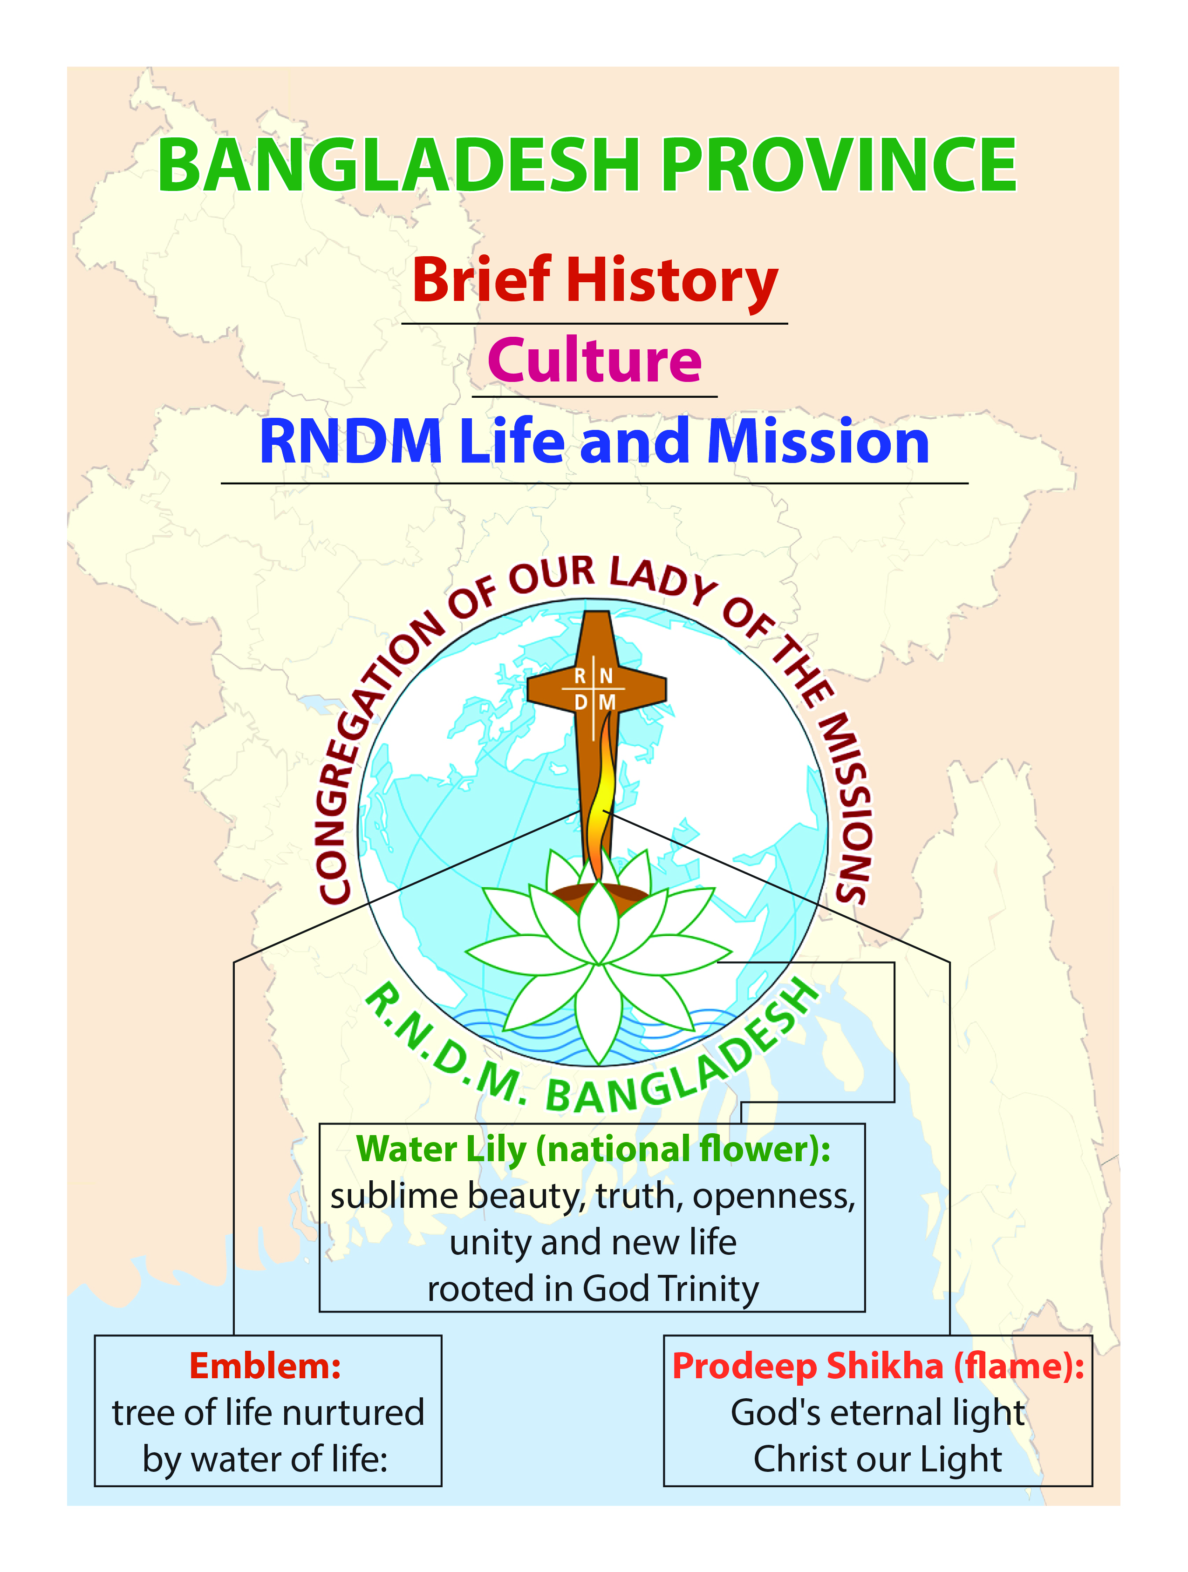
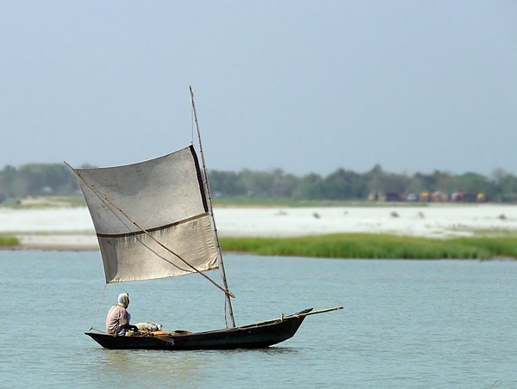
Bangladesh known as Tagore’s “Golden Bangla” is a low lying riverine country, situated on the northern coast of the Bay of Bengal. It is surrounded by India, with a small border with Myanmar in the Southeast. The two biggest rivers – Padma and Brahmaputra which originate in the Himalayas run through Bangladesh and flow into the Bay of Bengal and thus the country is vulnerable to flooding. In addition tropical monsoon and cyclones inflict frequent damage in the delta region.
The country constitutes with the major portion of the ancient and historic region of Bengal. The history of the region is closely entwined with the history of Bengal and the history of Indian sub-continent. Modern Bangladesh emerged as an independent nation after achieving independence from Pakistan in the Bangladesh liberation war of 1971.

Population: Bangladesh is one of the most densely populated countries in the world. It has a total population of approximately 172,954,319 million and the growth rate is 1.03% in 2023, Muslims 91.04%, Hindus 7.93%, Buddhist 0.61%,
Christians 0.30% and Animists 0.12%
Bangladesh is one of the most densely populated countries in the world
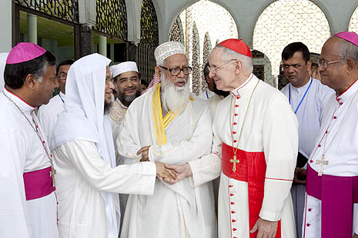
Interfaith Dialogue: We believe that Bangladesh is a model of interreligious harmony. His Eminence Cardinal Jean-Louis Tauran, the President of the Pontifical Council for Inter-religious Dialogue, visited us in April 2011. “I’ve said a number of times during my stay here that Bangladesh is considered as an example, a model for interreligious dialogue and harmony. It can be placed at the services of world today,” said Cardinal Tauran. The people of Bangladesh are known for their hospitality, rich cultural diversity, generosity and willingness to help others.
His Eminence Cardinal Jean-Louis Tauran, the President of the Pontifical Council for Inter-religious Dialogue, visited us in April 2011

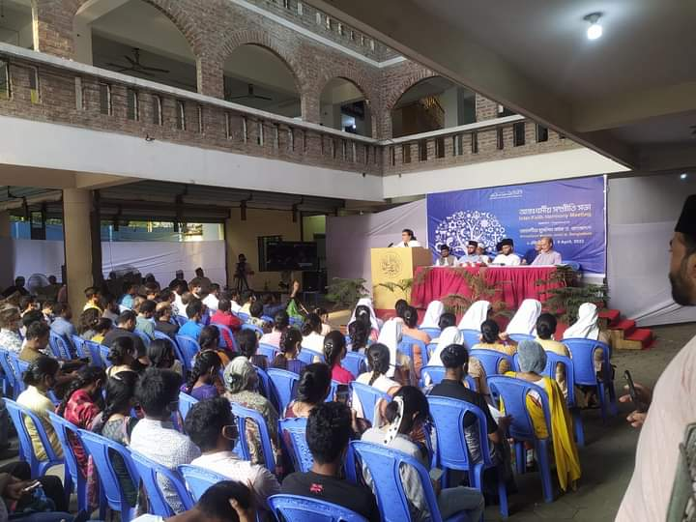
Through our school education ministry, we do practice ‘dialogue of life and dialogue of action’ in which people of different faiths and spiritual traditions strive to live in an open and neighborly spirit – includes socializing and hospitality and dialogue of action. Through our schools and charity work, family visiting, organizing seminars and conference on interfaith dialogue, we promote harmony between all people regardless of their faith.
Sr. Purobi Pascalina Chiran, RNDM delivering her valuable speech in Inter Faith Dialogue Seminar
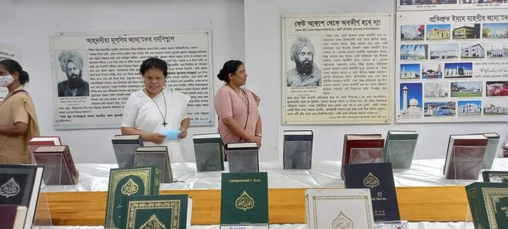
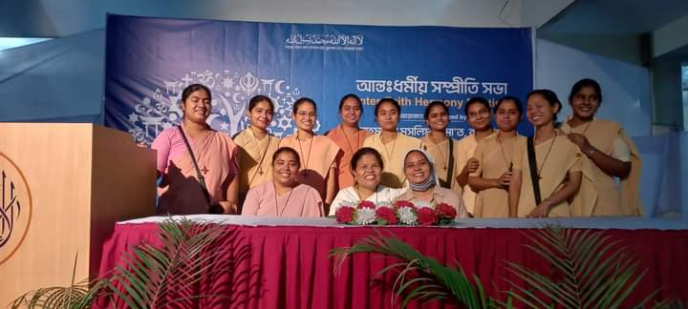
RNDM Province Leader Sr. Purobi Pascalina Chiran, RNDM and the Province Leadership team members are visiting the Holy Quran Display at Bakshibazar, Dhaka
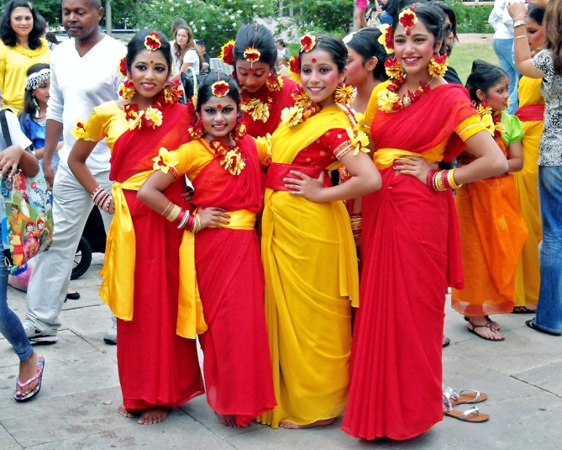
Culture: The land, the rivers and the lives of the Bangladeshis’ formed a heritage with marked differences with neighboring regions. The culture of Bangladesh is composite and assimilated influences of Islam, Hinduism, Buddhism and Christianity. It is manifested in various forms including music; dance and drama; art and craft; folklore and folktale; languages and literature; philosophy and religion; festivals and celebrations as well as distinct cuisine and culinary tradition.
The culture of Bangladesh is composite and assimilated influences of Islam, Hinduism, Buddhism and Christianity
The tribal (Adivasi) race constitutes less than 1 percent of the total population.
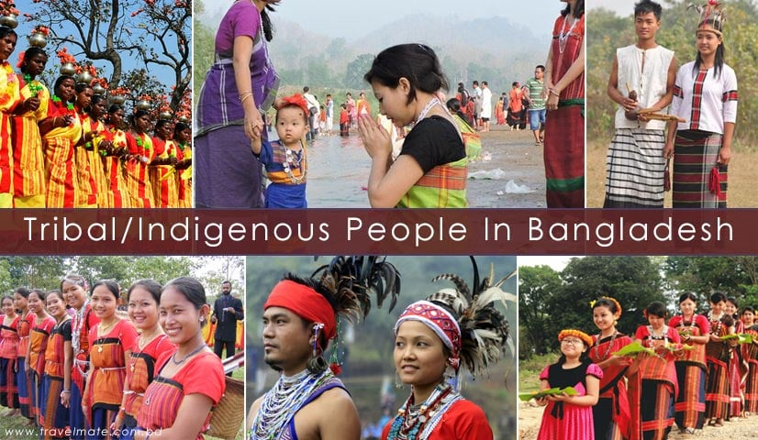
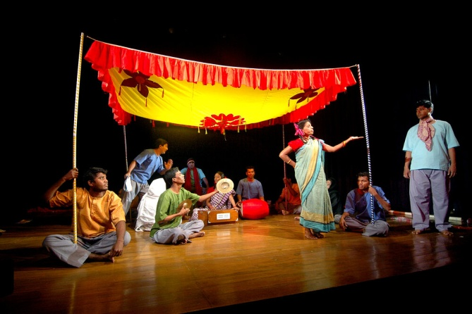
Dance and Drama
Tribal (Adivasi) race constitutes less than 1 percent of the total population.

They live in the Chattogram Hill Tracks and in the region of Mymensingh, Sylhet, Dinajpur and Rajshahi. They differ in their social organization, marriage customs, birth and death rites, food and other social customs from the people of the rest of the country.
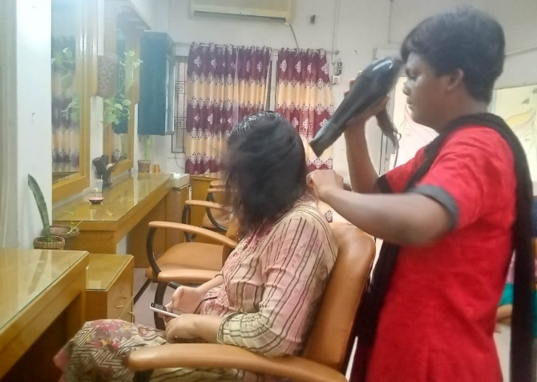
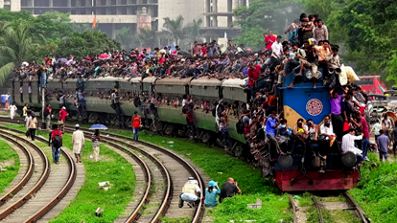
Migrant and Reality: Every day, some 2,000 people settle in the Bangladeshi capital Dhaka. It’s nothing new for generations the city has been a magnet for men and women escaping rural poverty. Dhaka has been the largest recipient of poor migrant from the eight different divisions. We assist migrant families, man and woman to ensure their voice in process of social dialogue to bring justice and relocation. We are monitoring to a family, teaching other people about migrants to stand beside them and help the victims of human trafficking particularly the migrants in Dhaka city.
Dhaka has been the largest recipient of poor migrant from the eight different divisions

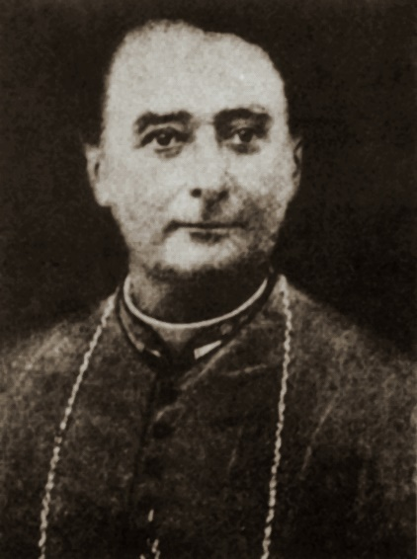
RNDM Presence in Bangladesh
At the invitation of Bishop Ballsieper, Vicar Apostolic of East Bengal, to establish a new foundation in Chattogram, East Bengal, five pioneer Sisters - Mother Mary of the Sacred Heart, Mother Mary of the Nativity, Sister Mary St. Philip, Sister Mary Stanislaus and Sister Mary St. Veronica left France on 11 February 1883 and commenced a long and most challenging journey by ship. They had a brief stop in Calcutta where they participated in the Holy Week services.
Bishop Edward Jordain Ballsieper, Vicar Apostolic of East Bengal

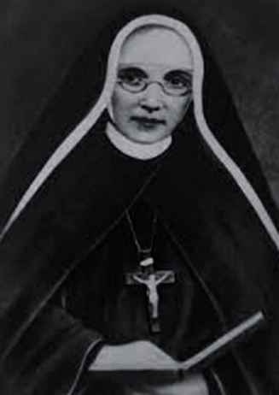
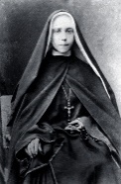
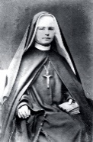
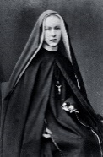
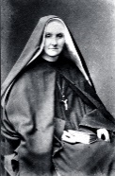
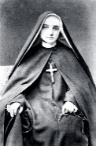
On 25 March 1883, Easter Sunday the valiant missionaries arrived in Chattogram. On their arrival, Euphrasie Barbier and her five companions knelt and kissed the ground, recognizing the sacredness of the land of “Golden Bengal”- the first foundation in Asia which they wanted to fully adopt and her people among whom they would serve.
Mother Euphrasie Barbier
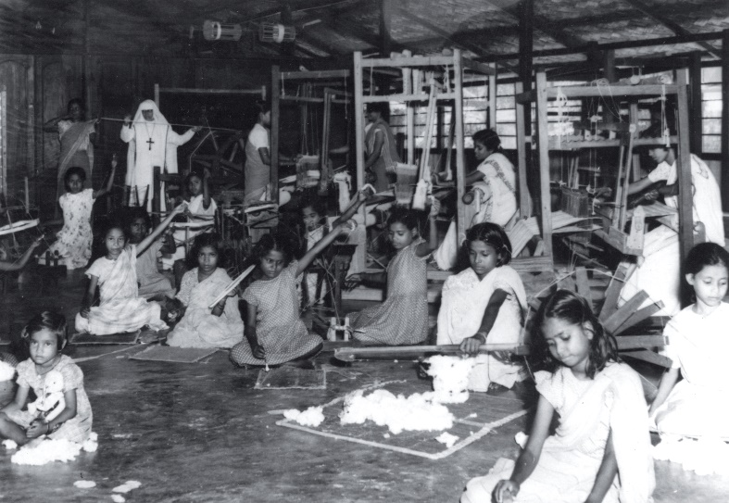
At this time the Diocese of Chattogram had a population of 2 million, but only about 17,000 were Catholics with eight Benedictine Priests and the Bishop to care for them. The RNDMs were then the only community of Religious Women. In the first month, the Sisters including Euphrasie Barbier began to learn the local languages - Hindi and Bengali. One month after their arrival, they opened two classes for poor children.

Within a short period, they opened a high school for fee paying students, a boarding school and an orphanage. Euphrasie also commenced catechism classes for young girls who were preparing for marriage. The Sisters were deeply touched and saddened by the plight of women and young girls who were forced into marriage at a very young age. To help out these women, the Sisters opened a work room for them where they worked to maintain their livelihood.
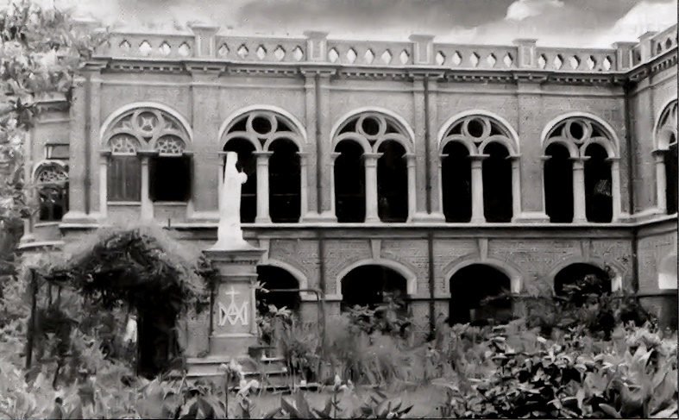
When the Congregation was founded in Bengal, Asia - there was a constant movement of Sisters and many zealous and dedicated RNDM missionaries from Australia, British Isles (UK), Canada, France, Ireland and New Zealand rendered their untiring services to the province at different levels and in various fields of ministries.
It is noteworthy that when the Congregation was founded in Asia in 1883, it was known as the Indian Province which comprised of India, Burma (Myanmar) and East Bengal (Bangladesh) with the Provincial House and Novitiate being in Chattogram. Although in 1947, India and Pakistan achieved independence as two separate countries, the Congregation in Asia continued as one province, having the Provincial House and Novitiate in Chattogram.
Mother house, Chittagong - 1886
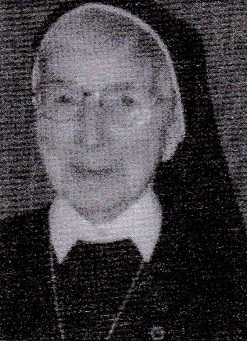
In 1962, a war broke out between India and China – the Himalayan border being the main issue of the war. At this time some of our Indian Sisters in Chattogram were almost put in the concentration camp there but at the plea and assurance of Sister Mary Desmond O’Hara, then the Provincial Superior, the Sisters were more or less under house arrest at St. Scholastica’s Convent, Chattogram.
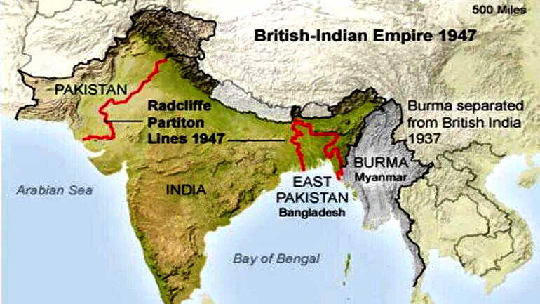
Finally political unrest, upheaval, undue tension and difficulty in communication contributed to the division of the province and creation of three regions – East Pakistan (Bangladesh), India and Burma (Myanmar).
Sister Mary Desmond O’Hara, RNDM
Then on 16 December 1971, East Pakistan (Bangladesh) achieved Independence from Pakistan and henceforth known as Bangladesh.
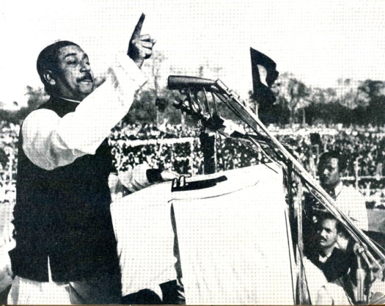
Soon after the creation of the three regions in this part of Asia and more so after Vatican II, the number of Sisters coming from the Western/European provinces gradually decreased and only one valiant missionary, Sister Mary Barbara McLoughlin, RNDM from Ireland who has been with us for the past almost 50 years and in 2015 she too went back.
Father of the Nation Bangabandhu Sheikh Mujibur Rahman

OUR VARIOUS MINISTRIES

Chattogram (1883): St. Scholastica’s & Novitiate
In addition to some new ministries, Sisters at St. Scholastica’s continue with the work began by Euphrasie Barbier and the Pioneer Sisters.
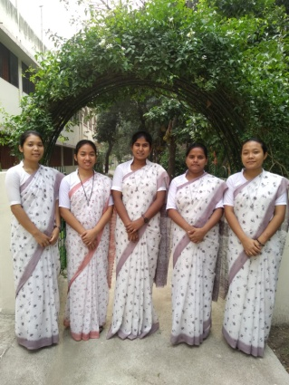
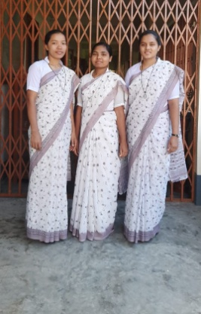
- Ministry of Formation: We are blest with vocations and have three second year novices and five postulants.
Postulants

- Education Ministry: Formal education is still an urgent need and is one of our main ministries in Bangladesh.
Second Year Novices
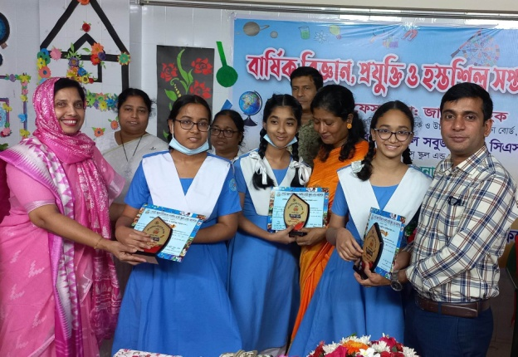
- St. Scholastica’s Girls School and College is with 2,600 students
- St.Scholastica’s Kindergarten has 850 students.

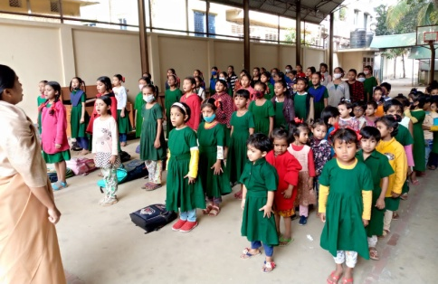

St. Scholastica’s Girls School and College

- Don Bosco Afternoon School:
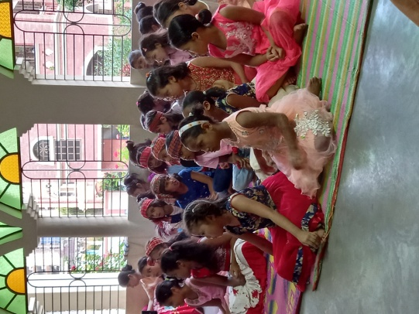
Don Bosco Afternoon School is for the under-privileged children. She has 150 students and most of whom are children of fishermen. Visiting the families of these children is an important ministry of the Novices, Postulants and Sisters here.
Don Bosco Afternoon School

- St. Benedict’s Crèche:
We have 19 girls and one boy from irrespective of caste and religion. Most babies who live in St. Benedict’s Crèche are not orphans. They have one or more living parents who come from extreme poverty and low-income families.

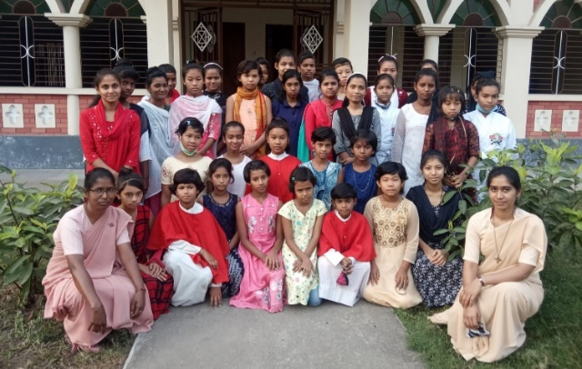
St. Benedict’s Crèche

- St. Peter’s Orphanage:
Girls from St. Benedict’s Crèche come to St. Peter’s Orphanage and continue their studies either in St. Scholastica’s Girls High School and college or in the Don Bosco Afternoon School or Yakub Ali Dubash Girls High School. At present there are 33 girls. Almost all of them have at least one living parent. Some of them have extended family. They are from very poor families and rely on St. Peter’s Orphanage to get good education and basic needs.
St. Peter’s Orphanage

- Pastoral Work: Sisters are actively involved in various parish committees and activities e.g. preparation for sacraments – First Communion, Confirmation and Marriage, liturgy, taking the Holy Communion to the sick, family apostolate, marriage encounters, youth ministries - Holy Childhood and Young Christian Student (YCS) movement, BCSM.

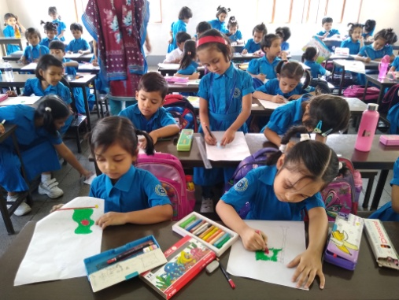
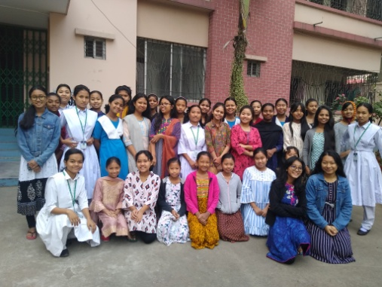
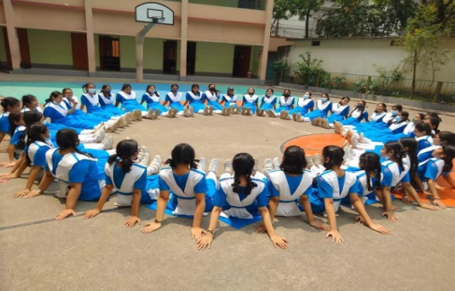
Luxmibazar, Dhaka-1 (1912): St. Francis Xavier’s Girls School
St. Francis Xavier’s Evening School
St. Francis Xavier’s Girls’ Hostel
St. Francis Xavier’s Girls School and College

- St. Francis Xavier’s Girls’ School and College: It has about 3,500 students.

- St. Francis Xavier’s Kindergarten: It has1,200 boys and girls students.
- St. Francis Xavier’s Evening School: There are 190 students from Nursery to class II. We have children of cobblers (low caste Hindus) and some poor children of the area irrespective of caste and religion.
- St. Francis Xavier’s Girls’ Hostel: At present there are 48 young girls who are studying in St. Francis Xavier’s Girls’ School and College. These girls are from distant parishes of the city as well as other parts of Bangladesh.

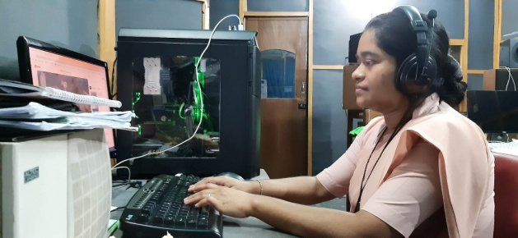
- Christian Communication center: Administrative work at the Christian Communication center, Radio VERITAS and Banidipti (the recording Center).

- Pastoral Work: Sisters are actively involved in different committees and pastoral activities of the parish, e.g. sacramental (First Communion, Confirmation and Marriage) and liturgical preparation, bringing sacrament to the sick, family apostolate, youth ministries –YCS, BCSM and Holy Childhood,
Administrative work at the Christian Communication center, Radio VERITAS and Banidipti (the recording Center

Golla (1914): St. Thecla’s
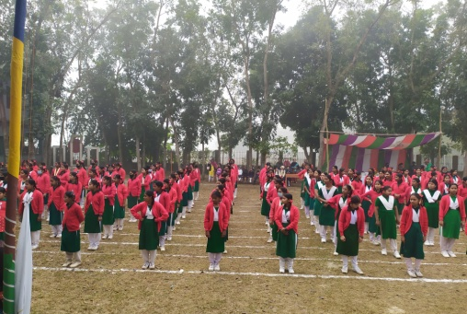
- St.Thecla’s Girls’ High School: It has 295 students.
- Dominic Savio Primary School
The school is only for Catholics boys and girls mainly for the faith formation of young children. It has 90 students.
- Pastoral Work: Sisters are actively involved in various parish committees and activities. e. g. preparation for sacraments and liturgy, taking the Holy Communion to the sick and elderly, family apostolate, marriage encounters, youth ministries- BCSM, YCS, Holy Childhood, Legion of Mary.
St. Thecla’s Girls’ High School

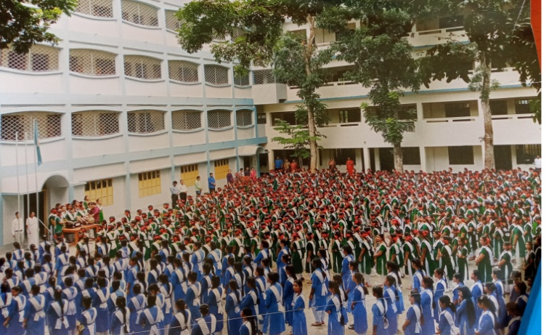
Hashnabad (1932): St. Euphrasie’s

- St. Euphrasie’s Girls School and College has 1,500 students
- St. Don Bosco Primary School is for only Catholic students and has 84 students.

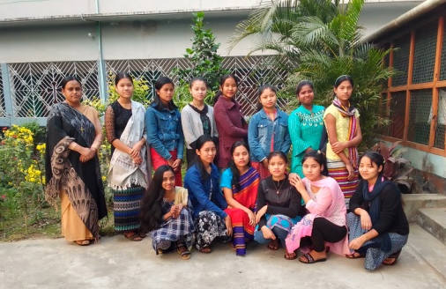
St. Euphrasie’s Girls School and College
- Euphrasie’s Girls’ Hostel:
There are 18 girls who are studying at St. Euphrasie’s Girls School and College.

Euphrasie’s Girls’ Hostel

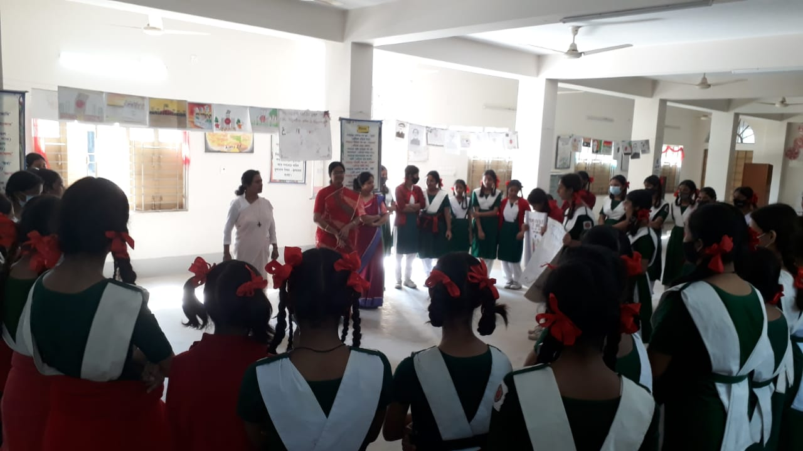
- Pastoral Work: Sisters are actively involved in visiting families, different parish committees, preparation for sacraments, taking the Holy Communion to the sick and elderly, family apostolate, marriage encounters, youth ministries- BCSM, YCS, Holy Childhood, Legion of Mary, St. Vincent De Paul, prayer and Mass in the villages during Lent and Advent season.
Sisters Lovely with the YCS Students
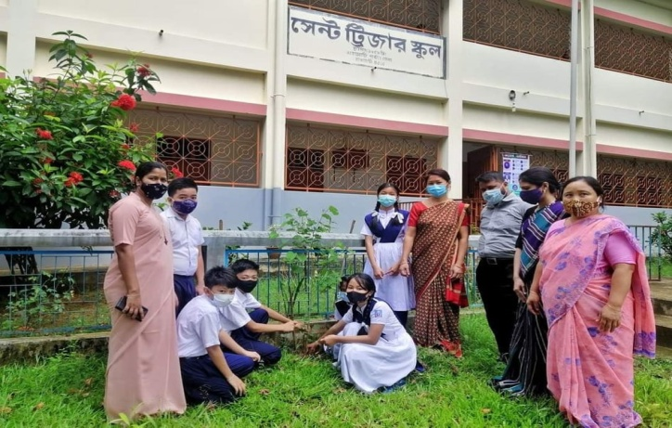
Rangamati (1959) St. Teresa’s
- St. Teresa’s High School: There are 650 students and mostly from different tribes.
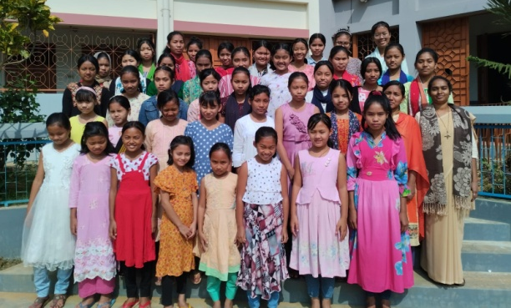
St. Teresa’s High School
- St. Teresa’s Girls’ Hostel: This hostel is for the tribal girls which provide shelter and better opportunities for about 50 tribal girls to continue their studies at St. Teresa’s High School.
St. Teresa’s Girls’ Hostel
- Pastoral Work: Sisters are actively involved in the Parish work, sacramental and marriage preparation, and visiting distant tribal villages, bring back the drop-out Catholics and assist in regularizing the illegal marriages.

Mohammadpur, Dhaka 7 (1967): Provincialate, Proggaloy, Marialoy
There are three communities within the same compound and have the following ministries:
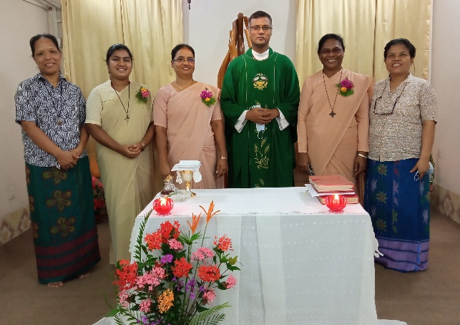
- Provincialate community:
The administration of Province Leadership Team and Provincialate community where Province Bursar, Assistant Province Bursar and Province Secretary are included.
Provincialate Community

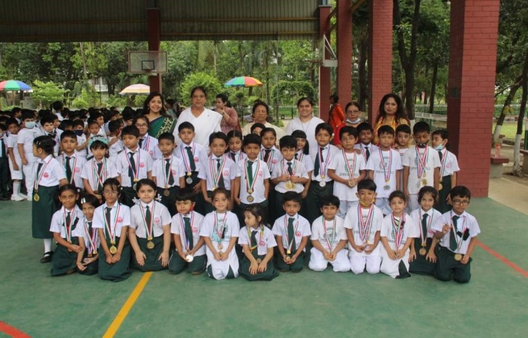
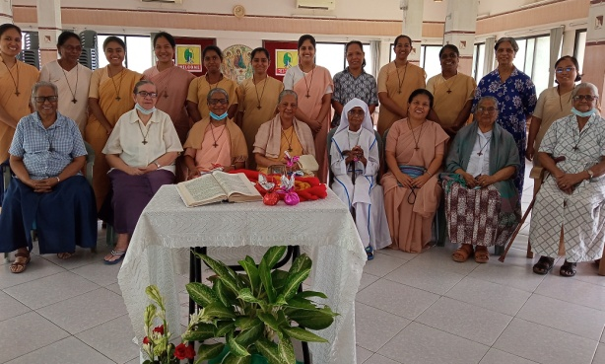
- Proggaloy Community: (Home of Wisdom Sisters): Some of our senior Sisters, who have worked for many years in various places and active ministries and now retired as well sick. They live in a special built facility building for their comfort. It is a real power house of prayer as these Sisters support our province and the congregation with their prayer and encouragement. May 15 is Feast Day of Proggaloy Community. Our Elderly Sisters by their wisdom, insight, prayers, affection, tenderness and their loving kindness bear witness to God’s truthfulness.
Proggaloy - Home of Wisdom Sisters

- S.F.X. Greenherald International School - preparing students for the Cambridge Examinations at different levels. It caters for about 1200 students. Nine Sisters are actively engaged in this apostolate.
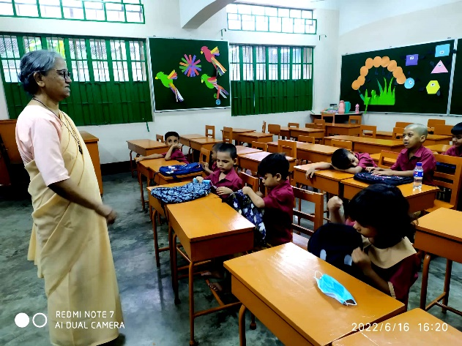
S.F.X. Greenherald International School
- SFX Afternoon (Charity) school: The school is for the under-privileged- non-Bengali children who live in various refugee camps around the area. This ministry is supported and administered by Greenherald International School and has 160 students.
S.F.X. Afternoon (Charity) school

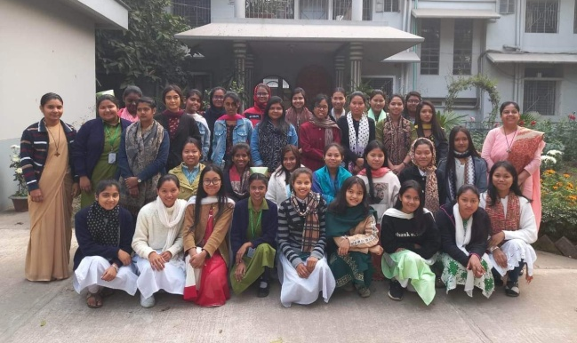
- Trinity Girls’ Hostel: Trinity Hostel is for the girls (ages 16-25) who attend different colleges and universities in Dhaka. Priority isgiven to faith formation of these youngwomen. There are 78 girls.

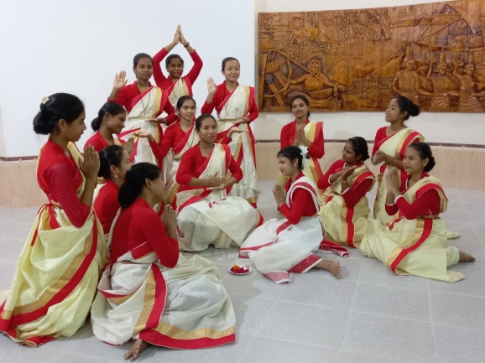
Aspirancy:
Trinity Girls’ Hostel
The young women who are discerning their vocation to the RNDM way of life are formed and guided by their directress. At present there are 25 young girls. Thanks be to God.

Aspirants
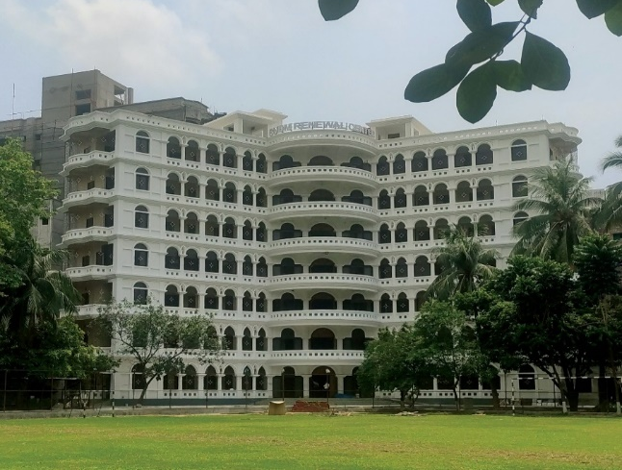

- RNDM Renewal Center:
It is a center for prayer, seminar, conference and spiritual counseling which is open for all who wish to come. It is also a place for personal and group Retreats.

RNDM Renewal Center
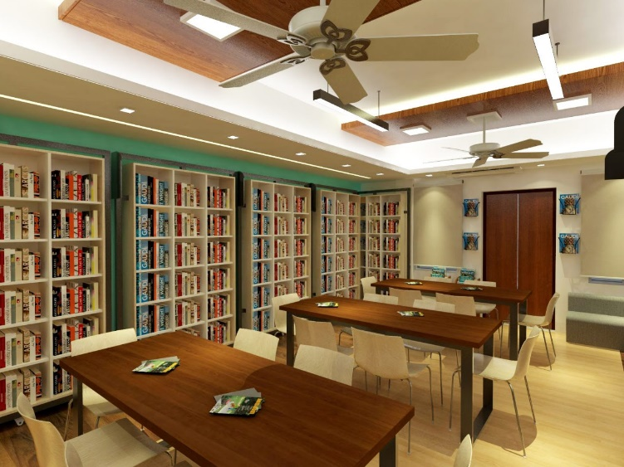
- Euphrasie Barbier Library:
Euphrasie Barbier Library is designed by Mr Domion Neuton Penheiro (Titu) sir and his companions according to the Province Leadership Team directions. It was a dream for the province to have a Central Province Library and it is now fulfilled.

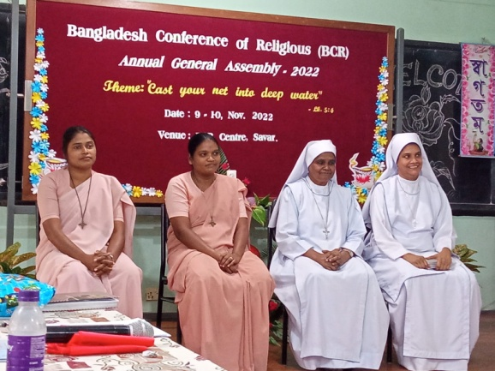
Euphrasie Barbier Library

- BCR Center, Savar: Administrative work at the center for Bangladesh Conference of Religious (BCR). Our RNDM Sisters are responsible for two years from 2023-2024. The Bangladesh Conference of Religious organizes different programs at the BCR Centre, Savar, Dhaka for all the Religious communities.

BCR Center, Savar

- Active involvement in different parish committees, visiting families, preparation for sacraments, marriage encounters, youth ministries- BCSM, YCS, Holy Childhood.

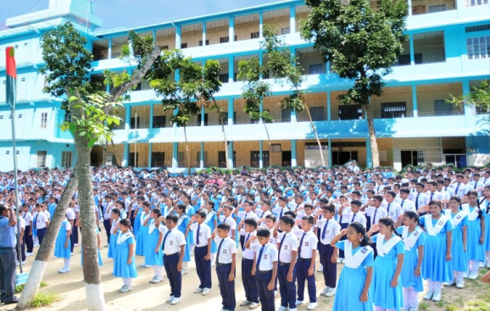
Sreemongal (1974): St. Martha’s

St.Martha’s High School:

St. Martha’s High School is mainly for tribal students of the area. It has 800 Students.

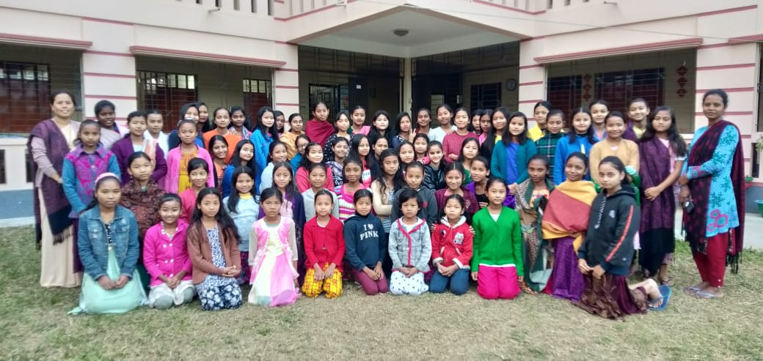
St. Martha’s Kindergarten: It is for the local children and has 200 Students.
St. Martha’s High School

- St. Martha Girls’ Hostel: it is for Adibashi (tribal) girls of different tribes. It has 75 girls who are studying in St. Martha’s High School.
St. Martha Girls’ Hostel

- Pastoral Work:
Sisters are working among different tribal people (Khasi, Garo, Santal, Oraon) - adult faith formation, Youth formation and family apostolate, Sacramental and Liturgical preparation, Faith formation of young boys and girls residing in different hostels run by lay people.
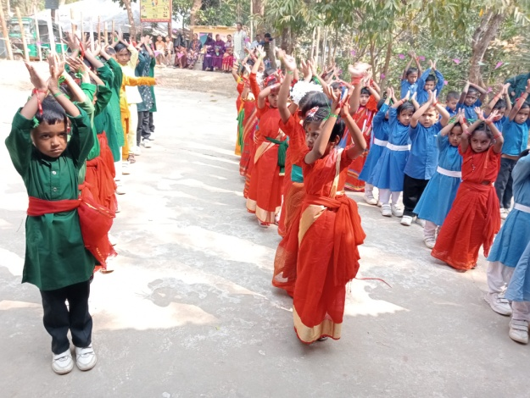

Diang (1978): Miriam Ashram

Mariam Ashram Holy Childhood School: Sisters give good foundation to little children from cobbler and fishermen villages and nearby other poor daily workers. There are 95 students.
Mariam Ashram Holy Childhood School

Mariam Ashram Health Center: Antenatal care, treatment of children suffering from Mal- nutrition and child diseases, give advice to pregnant mothers and on preventive methods.
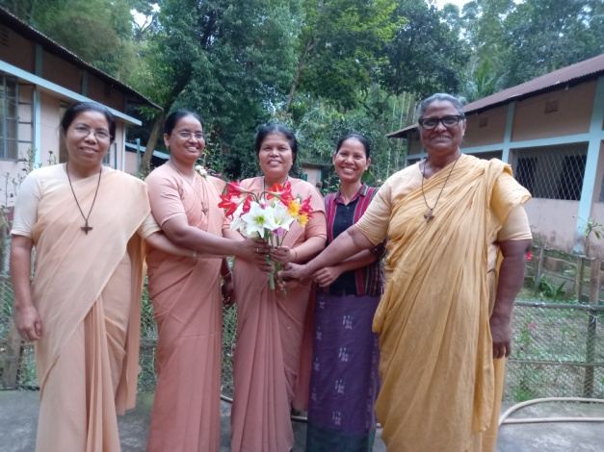

- Pastoral Ministry: Involved in different parish committees, Sacramental and liturgical preparation, taking the Holy Communion to the sick and elderly, family apostolate, marriage encounters, youth ministries- BCSM, YCS, Holy Childhood, Legion of Mary, St. Vincent De Paul, prayer and Mass in the villages during Lent and Advent season, Faith formation of young boys and girls and Visiting families.

Sr. Purobi Pascalina Chiran, RNDM, Superior, Bangladesh province along with sr. Himani , RNDM visiting the Diang community

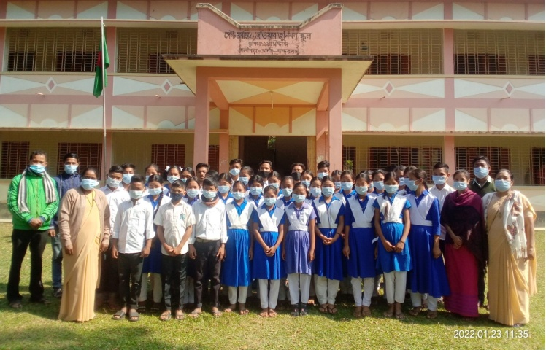

Bolipara (1990): Sraboninak

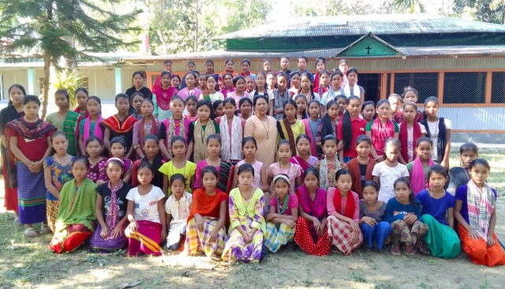
St. Xavier’s Junior School: Administration and Teaching in Junior High School. It has 170 Students who are belong to different tribes.
St. Xavier’s Junior School

St. Xavier’s Dispensary: Treatment for malaria, seasonal and minor illnesses, snake bites and first aid for the School students.

- St. Francis Xavier’s Hostel: There are 90 girls in the hostel where the Sisters give Christian and ethical formation in addition to assisting them with their academic studies.
St. Francis Xavier’s Hostel
- Pastoral Work:

Sisters are involved in different parish committees, Sacramental and liturgical preparation, family apostolate, marriage encounters, youth ministries- BCSM, YCS, Holy Childhood, St. Vincent De Paul, prayer and Mass in the villages during Lent and Advent season, Faith formation of young boys and girls, Visiting families in distant villages and supporting them with valuable advice and encouragement, assists in regularizing illegal marriages.

Natore (1993): Mariam Niketan

Mariam Junior High School:

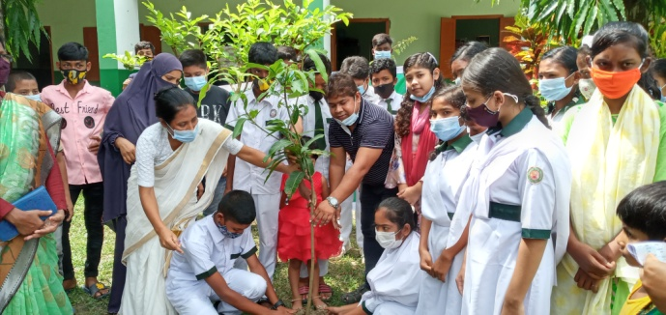
Administration and teaching in Junior High School. It is situated in Muslim and Hindu area. It has 250 students.

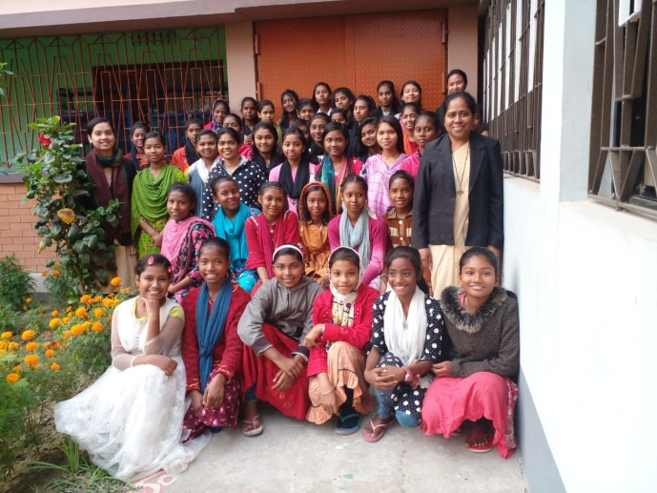
Mariam Junior High School

St. Sylvia Girls’ Hostel: It is the Shelter and good education for under-privileged tribal / Adibashi girls, poor ones, Christian and ethical formation. There are 45 girls.

- Pastoral Work: Sacramental and liturgical preparation, visiting families near and in distant villages- supporting them with valuable advice and encouragement, dialogue with people of other faiths and life witness.
St. Sylvia Girls’ Hostel
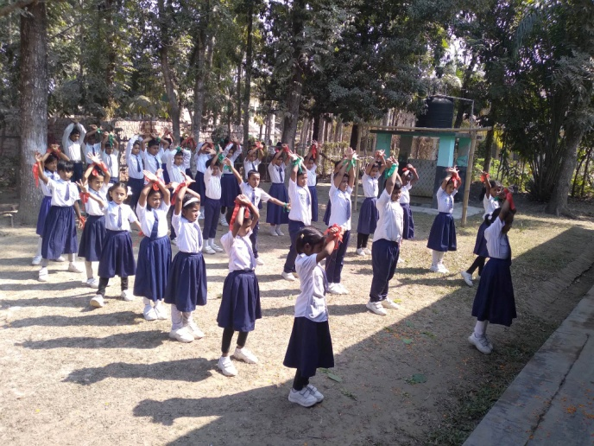
Bagerhat (1995): Jyotidham

- St. Joseph’s Primary School: Administration and teaching in Primary School. It has 150 students.

- Pastoral Work: Sisters are involved in different parish committees, Sacramental and liturgical preparation, family apostolate, marriage encounters, youth ministries- BCSM, YCS, Holy Childhood, St. Vincent De Paul, prayer and Mass in the villages during Lent and Advent season, assists in regularizing illegal marriages, Faith formation of young boys and girls.
St. Joseph’s Primary School
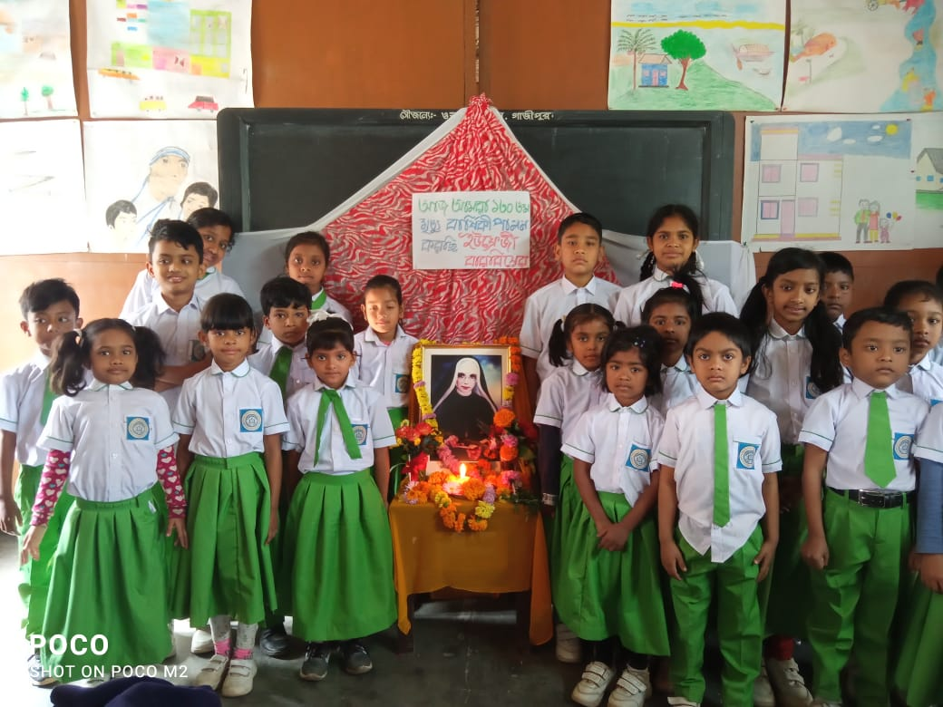

Bhadun (2007): Deepaloy
- Fatima Rani Primary School: There are 70 students and Sisters are involved in school administration as well as teaching.
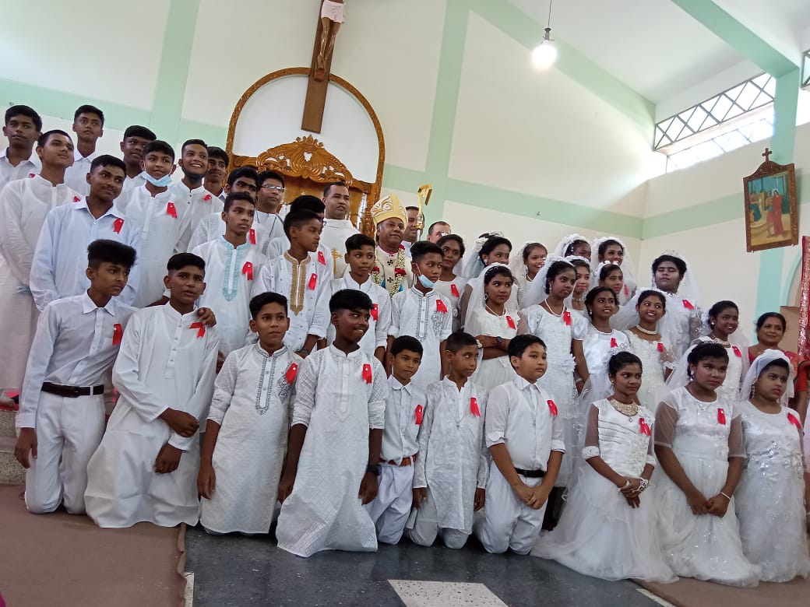
Fatima Rani Primary School
- Pastoral Work: Involvement in parish pastoral committee; sacramental and liturgical preparation; visiting families,taking the Holy Communion to the sick and elderly, youth ministries- BCSM, YCS, Holy Childhood, St. Vincent De Paul, prayer and Mass in the villages during Lent and Advent season, Faith formation of young boys and girls.
Received Holy Communion
Jhaljolia (2007): St. Clara’s
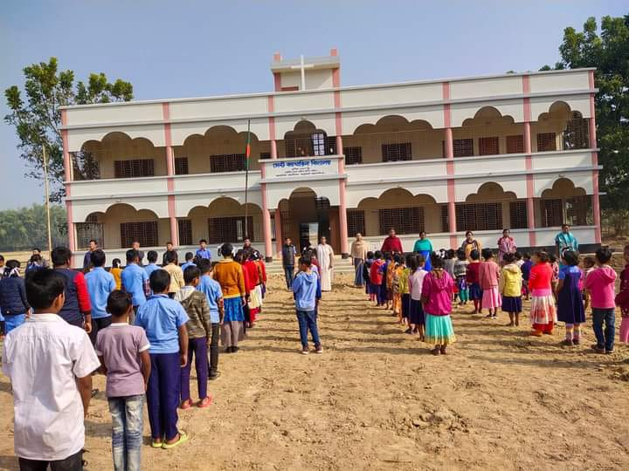
- St. Catherina Primary School: The Sisters are involved in the school administration and teaching for tribal boys and girls- mostly Garo tribe. There are 105 Students.

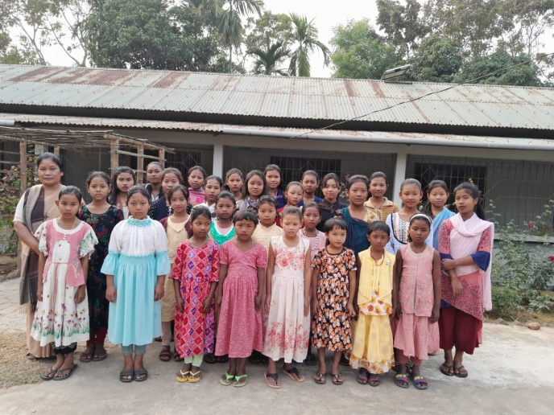
St. Catherina Primary School

- St. Clara’s Girls’ Hostel: Supervision of Hostel, giving Christian and ethical formation in addition to assisting them with their academic studies. There are 45 Students.

St. Clara’s Girls’ Hostel

- Pastoral Work: Involvement in parish pastoral committees, sacramental and liturgical preparation; visiting families, taking the Holy Communion to the sick and elderly, youth ministries- BCSM, YCS, Holy Childhood, St. Vincent De Paul, prayer and Mass in the villages during Lent and Advent season, Faith formation of young boys and girls.

Gournadi (2015): Sacred Heart Convent
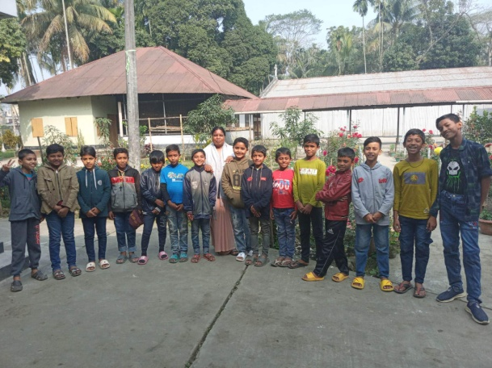
- St. Joseph’s Primary School: The Sisters are involved in the administration and teaching in Primary School. It is run by the Barisal Diocese. It has 270 Students.
- St. Joseph’s Boys’ Home: Sisters are involved in supervision of the Home (shelter) for the small boys who come from distant villages for education and Christian formation. There are 18 boys.
St. Joseph’s Boys’ Home

- Pastoral Work: Involvement in parish pastoral committees, sacramental and liturgical preparation; taking the Holy Communion to the sick and elderly, youth ministries- BCSM, YCS, Holy Childhood, St. Vincent De Paul, prayer and Mass in the villages during Lent and Advent season, Faith formation of young boys andgirls, Visiting families of Christians and non-Christians around the area and in different sub-centers (out stations) of the parish.

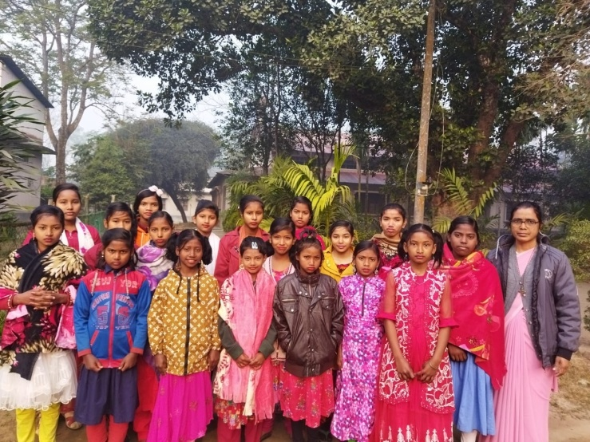
Bhotepara (2012): Barbier House
- Supervise the hostel for the under-privileged Adibashi Girls mostly Shantel, Pahari. Giving Christian and ethical formation in addition to assisting them with their academic studies. There are 18 girls only.

- Pastoral work: Visiting families, involvement in parish pastoral committee, visiting and living with the people in sub-centers (out stations) of the parish, visit the sick and give sacrament to them, sacramental and liturgical preparation in the parish.
Barbier Girls’ Hostel, Bhotepara
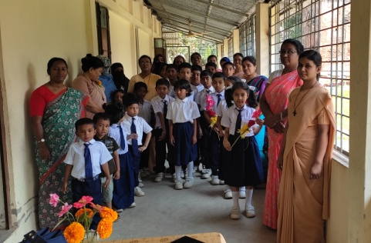
Lokhipur (2017): Visitation Convent

- St. Joseph’s Missionary School: The Sisters are involved in the administration and teaching in this Primary School. It is run by the Chattogram Diocese. It has 30 Students only.
St. Joseph’s Missionary School

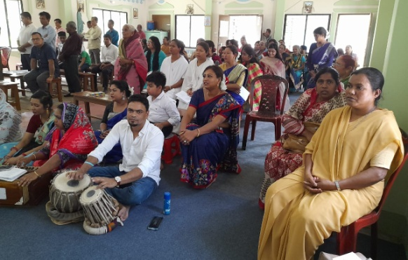
- Pastoral Work: Involvement in parish pastoral committees, sacramental and liturgical preparation; taking the Holy Communion to the sick and elderly, youth ministries- BCSM, YCS, Holy Childhood, St. Vincent De Paul, prayer and Mass in Shahebgonj- sub-center (out station) of the parish, Faith formation of young boys and girls and Visiting families.

Sisters serving in Foreign Land
France:
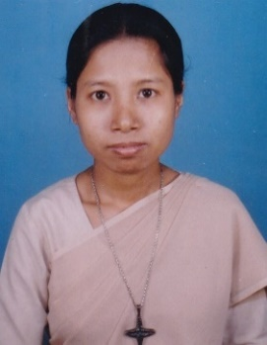
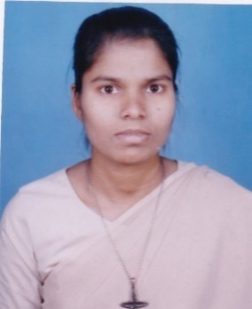
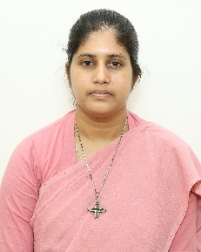
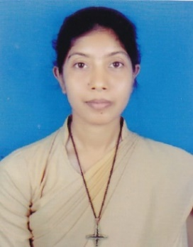
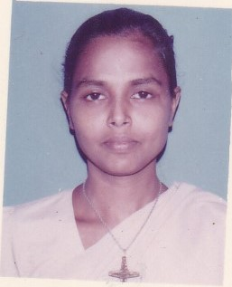
Sr. Rebecca Karmokar Sr. Regina Tripura Sr. Cecilia Gomes Sr. Beauty Gosal Sr. Maryline Cruze

Phil
P
Phillipines
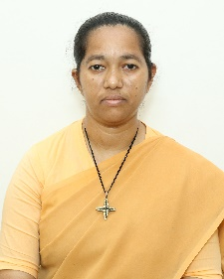
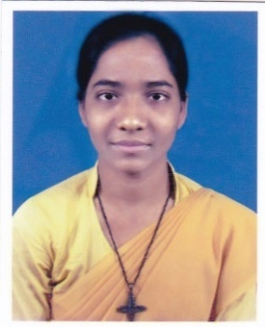
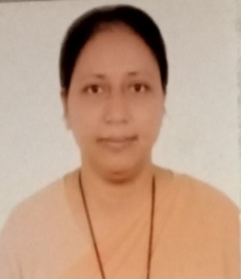

Sr. Shongita Gomes Sr. Nipa Pereira Sr. Shukhi Hembrom
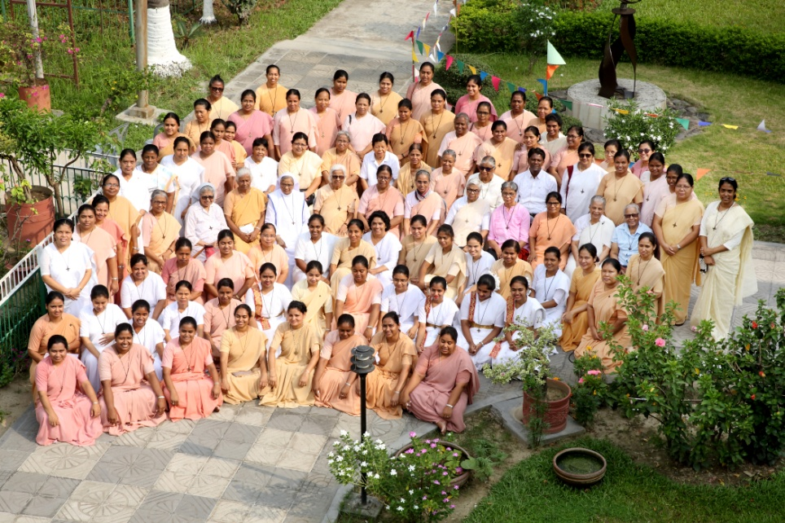

“Ad Majorem Dei Gloriam”

(Whatever you do, do it all for the glory of God)

1 Corinthians 10:31

