SISTERS OF OUR LADY OF THE MISSIONS
INTERNATIONAL MISSION DEVELOPMENT OFFICE
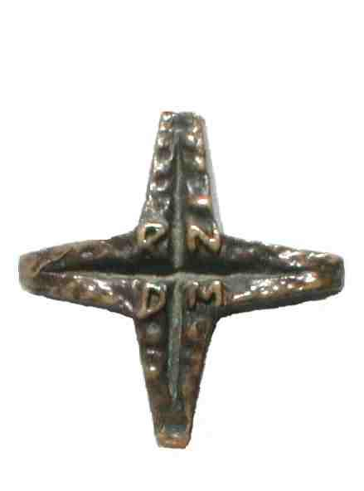
PO Box 4037, Balwyn Vic 3103
Email: cbrabender@bigpond.com

PARTNERSHIP IN MISSION FORM
STEP ONE
I wish to participate in the mission of the Sisters of Our Lady of the Missions as a Financial Partner through:
 |  |  | Annual donation |  |  | Quarterly donation Monthly donation Other
 |  |  | I wish this donation to be used for (Name Specific project) ......................................................................................
 |  |  | I wish this donation to be used for the most urgent needs
 |  |  | The education of young RNDM sisters
 |  |  | I wish to make a bequest in my will to the Mission of the Sisters of Our Lady of the Missions
 |  |  | I would require a tax deductible receipt
STEP TWO
 | Name
 | Address
 | Suburb |  |  |  |  |  |  | Post code
 | Phone : Home |  |  |  |  |  |  | Mobile
 | Email
STEP THREE
 |  |  | Enclosed is my gift (cheque, money order) |  |  |  |  |  | $25 |  | $50 |  | $100 |  | Other
 |  |  | Payable to: |  | Sisters of Our Lady of the Missions
 |  |  | Mail to: |  | IMDO PO Box 4037, Balwyn Vic 3103 Australia
 |  |  | Arrangements can be made for direct credit into the Province Bank account, if this is more convenient
 |  |  | Please charge my credit card: |  |  |  | Mastercard |  |  | Visa
TAX DEDUCTABLE RECEIPT REQUIRED YES/NO

Card Number
 |  |  | Name on Card
 |  |  | Expiry Date
 |  |  | Signature
Email to: cbrabender@bigpond.com
We thank you for your generosity

